PERSONAL DATA

|  |  |
| --- | --- |
| **Name:** | Hennadii Sapryka |
| **Date of Birth:** | 04/08/1979 |
| **Location:** | Ukraine, Lviv |
| **Mobile:** | +38 (067) 310-03-04 |
| **E-mail:** | hennadii.sapryka@gmail.com |
| **LinkedIn:** | **www.linkedin.com/in/hennadii-sapryka** |

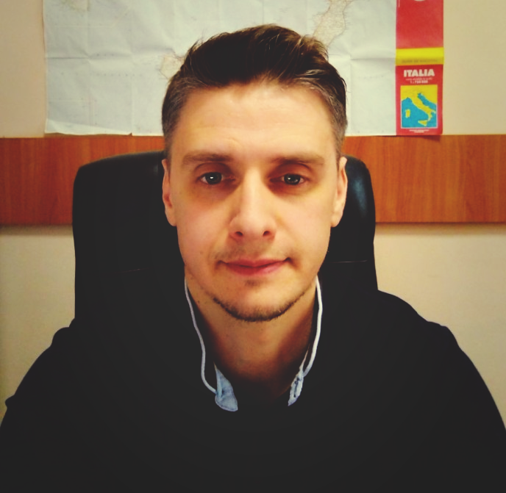

OBJECTIVE

|  |  |
| --- | --- |
| **Desired Position:** | junior .Net developer |

SUMMARY OF QUALIFICATION

|  |
| --- |
| I have been working in law enforcement since 2000. I take part in the detection of crimes against life and health, in the field of economics, organized crime, as well as in the fight against cybercrime. Since of the beginning 2020, I have been actively studying the C # language and .NET technologies |

TECHNICAL SKILLS

* .NET Core, C#
* MVC, ASP.Net Web API, .NET Core,
* SQL, Entity Framework,
* HTML, CSS, Bootstrap
* Visual Studio

LANGUAGES

* English – pre-intermediate. Learning still in progress.

EDUCATION

* 1996 – 2000 /Lviv University of Internal Affairs, Faculty of Law /.   
  Bachelor of Law / Ukraine, lviv
* 2001 – 2003 /Commercial Academy, Faculty of Economic /.   
  / Ukraine, lviv

SEVERAL FACTS ABOUT ME

|  |
| --- |
| І married. I have two children.  I prefer a healthy lifestyle like traveling, swimming, and hiking.  I am free of the bad habits.  I am resistant to difficult working conditions.  I can find the optimal way from difficult situation by myself in short time period.  I have managerial experience (35 people).  I have an experience in public speaking. |

COURSES AND CERTIFICATES

|  |  |
| --- | --- |
| **Course name:** | Certificate of completion of the English language course |
| **Issued:** | [Acreading school CALLAN METHOD in Ukraine of Callan Method Organisation London](https://www.linkedin.com/search/results/all/?keywords=%D0%90%D0%BA%D1%80%D0%B5%D0%B4%D0%B8%D1%82%D0%BE%D0%B2%D0%B0%D0%BD%D0%B0%20%D1%88%D0%BA%D0%BE%D0%BB%D0%B0%20CALLAN%20METHOD%20%D0%B2%20%D0%A3%D0%BA%D1%80%D0%B0%D1%97%D0%BD%D1%96%20%D0%B2%D1%96%D0%B4%20Callan%20Method%20Organisation%20London) |
| **Years of study:** | 11/2019 – 11/2020 |
| **Certificate license number:** |  |
| **Files:** | https://hennadii-sapryka.github.io/certify.github.io/ |

PROFESSIOANL EXPERIENCE

|  |  |
| --- | --- |
|  | |
| **Company:** | Main Directorate of the National Police of Ukraine in Lviv Region |
| **Company Location:** | Ukraine, Lviv |
| **Duration:** | 09/2000 – present time |
| **Description:** | Law enforcement activities, prevention and detection of serious and especially serious crimes, using special equipment. |
| **Position:** | [security officer Major Crimes Unit, security administrator](https://www.linkedin.com/search/results/all/?keywords=%D0%93%D0%A3%D0%9D%D0%9F%20%D1%83%20%D0%9B%D1%8C%D0%B2%D1%96%D0%B2%D1%81%D1%8C%D0%BA%D1%96%D0%B9%20%D0%BE%D0%B1%D0%BB%D0%B0%D1%81%D1%82%D1%96), analyst – 2000-2017  division chief – 2017 - present time |
| **Overall Team Size:** | 32 unit officers, 6 crime analyst, 3 security administrator |
| **Responsibilities:** | * Installing and configuring software, hardware and networks * Ensuring security and efficiency of IT infrastructure * **Data Research and Analytics** * Creating visual schema, and analyst crime incident patterns * Creating database. Generate useful reports from database * Team management |
| **Tools & Technologies:** | **Tools:** IBM Security i2 Analyst's  **Languages & Technologies:** MS Access, SQL, Virtualization Technology (VMware) |